China Wireless Telecommunication Standard (CWTS);
Working Group 1 (WG1);
Multiplexing and channel coding

TS C103 V2.2.0 1999-10

Technical Specification
CWTS

Contents
1 Intellectual Property Rights 3
2 Foreword 3
3 Scope 3
4 References 3
5 Definitions, symbols and abbreviations 4
5.1 Definitions 4
5.2 Symbols 4
5.3 Abbreviations 4
6 Multiplexing, channel coding and interleaving 7
6.1 General 7
6.2 Transport-channel coding/multiplexing 7
6.2.1 Error detection 9
6.2.1.1 CRC calculation 9
6.2.1.2 Relation between input and output of the Cyclic Redundancy Check 9
6.2.2 Transport block concatenation and code block segmentation 9
6.2.2.1 Concatenation of transport blocks 9
6.2.2.2 Code block segmentation 10
6.2.3 Channel coding 10
6.2.3.1 Convolutional Coding 11
6.2.3.2 Turbo coding 12
6.2.3.2.1 Turbo Coder 12
6.2.3.2.2 Trellis termination in Turbo code 13
6.2.3.2.3 Turbo code internal interleaver 13
6.2.4 Radio frame size equalisation 17
6.2.5 1st interleaving 17
6.2.6 Radio frame segmentation 18
6.2.7 Rate matching 18
6.2.7.1 Determination of rate matching parameters 19
6.2.7.2 Bit separation for rate matching 21
6.2.7.3 Rate matching pattern determination 22
6.2.8 TrCH multiplexing 23
6.2.9 Physical channel segmentation 23
6.2.10 2nd interleaving 24
6.2.10.1 Frame related 2nd interleaving 24
6.2.10.2 Timeslot related 2nd interleaving 24
6.2.11 Physical channel mapping 25
6.2.11.1 Mapping scheme after frame related 2nd interleaving 26
6.2.11.2 Mapping scheme after timeslot related 2nd interleaving 26
6.2.12 Multiplexing of different transport channels onto one CCTrCH, and mapping of one CCTrCH onto physical channels 26
6.2.12.1 Allowed CCTrCH combinations for one UE 27
6.2.12.1.1 Allowed CCTrCH combinations on the uplink 27
6.2.12.1.2 Allowed CCTrCH combinations on the downlink 27
6.2.13 Transport format detection 27
6.2.13.1 Blind transport format detection 27
6.2.13.2 Explicit transport format detection based on TFCI 27
6.2.13.2.1 Transport Format Combination Indicator 27
6.3 Coding for layer 1 control 27
6.3.1 Coding of transport format combination indicator (TFCI) 27
6.3.1.1 Default TFCI word 28
6.3.1.2 Coding of short TFCI lengths 28
6.3.2 Operation of Transport-format-combination indicator (TFCI) in Split Mode 29
7 History 29

Intellectual Property Rights
<Editor’s note: this section will be completed when an official format for the document is agreed>

Foreword
This Technical Specification has been produced by the CWTS, Working Group 1 (CWTS WG1).
The contents of this TS may be subject to continuing work within the CWTS WG1and may change following formal TSG approval. Should the TSG modify the contents of this TS, it will be re-released with an identifying change of release date and an increase in version number as follows:
Version m.x.y
where:
m indicates [major version number]
x the second digit is incremented for all changes of substance, i.e. technical enhancements, corrections, updates, etc.
y the third digit is incremented when editorial only changes have been incorporated into the specification.

Scope
This CWTS Report describes multiplexing, channel coding and interleaving for CWTS Physical Layer TD-SCDMA mode.

References
- CWTS TS C102 (V2.0.0): “Physical channels and mapping of transport channels onto physical channels ”
- CWTS TS C101 (V2.0.0): “Physical layer – general description ”
- CWTS TS C104 (V2.0.0): “Spreading and modulation ”
- CWTS TS C105 (V2.0.0): “Physical layer procedures ”
- CWTS TS C002 (V2.0.0): “Service provided by physical layer”
- 3GPP TS25.222 (V2.2.0): “Multiplexing and channel coding (TDD)”

Definitions, symbols and abbreviations

Definitions
For the purposes of the present document, the following definitions apply:
<defined term>: <definition>.

Symbols
For the purposes of the present document, the following symbols apply:

⎡x⎤ round towards ∞, i.e. integer such that x ≤ ⎡x⎤ < x+1
⎣x⎦ round towards -∞, i.e. integer such that x-1 < ⎣x⎦ ≤ x
⎜x⎜ absolute value of x

Unless otherwise is explicitly stated when the symbol is used, the meaning of the following symbols are:
i TrCH number
j TFC number
k Bit number
l TF number
m Transport block number
n Radio frame number
p PhCH number
r Code block number
I Number of TrCHs in a CCTrCH.
C_{i} Number of code blocks in one TTI of TrCH i.
F_{i} Number of radio frames in one TTI of TrCH i.
M_{i} Number of transport blocks in one TTI of TrCH i.
P Number of PhCHs used for one CCTrCH.
PL Puncturing Limit for the uplink. Signalled from higher layers
RM_{i} Rate Matching attribute for TrCH i. Signalled from higher layers.

Abbreviations
ARQ | Automatic Repeat on Request
BCH | Broadcast Channel
BER | Bit Error Rate
BPSK | Binary Phase Shift Keying
BS | Base Station
BSS | Base Station Subsystem
CA | Capacity Allocation
CAA | Capacity Allocation Acknowledgement
CBR | Constant Bit Rate
CCCH | Common Control Channel
CCTrCH | Coded Composite Transport Channel
CD | Capacity Deallocation
CDA | Capacity Deallocation Acknowledgement
CDMA | Code Division Multiple Access
CTDMA | Code Time Division Multiple Access
CRC | Cyclic Redundancy Check
DCA | Dynamic Channel Allocation
DCCH | Dedicated Control Channel
DL | Downlink
DRX | Discontinuous Reception
DSCH | Downlink Shared Channel
DTX | Discontinuous Transmission
FACH | Forward Access Channel
FDD | Frequency Division Duplex
FDMA | Frequency Division Multiple Access
FEC | Forward Error Control
FER | Frame Error Rate
GF | Galois Field
HCS | Hierarchical Cell Structure
JD | Joint Detection
L1 | Layer 1
L2 | Layer 2
LLC | Logical Link Control
MA | Multiple Access
MAC | Medium Access Control
MAHO | Mobile Assisted Handover
MO | Mobile Originated
MOHO | Mobile Originated Handover
MS | Mobile Station
MT | Mobile Terminated
NRT | Non-Real Time
PC | Power Control
PCCC | Parallel Concatenated Convolutional Code
PCH | Paging Channel
ODMA | Opportunity Driven Multiple Access
QoS | Quality of Service
QPSK | Quaternary Phase Shift Keying
RACH | Random Access Channel
RF | Radio Frequency
RLC | Radio Link Control
RRC | Radio Resource Control
RRM | Radio Resource Management
RT | Real Time
RU | Resource Unit
SCH | Synchronisation Channel
SDCCH | Stand-alone Dedicated Control Channel
SFN | System Frame Number
SNR | Signal to Noise Ratio
SP | Switching Point
TCH | Traffic channel
TDD | Time Division Duplex
TDMA | Time Division Multiple Access
TFCI | Transport Format Combination Indicator
TrCH | Transport Channel
UL | Uplink
UMTS | Universal Mobile Telecommunications System
VBR | Variable Bit Rate

Multiplexing, channel coding and interleaving

General
Data stream from/to MAC and higher layers (Transport block / Transport block set) is encoded/decoded to offer transport services over the radio transmission link. Channel coding scheme is a combination of error detection, error correcting (including rate matching), and interleaving and transport channels mapping onto/splitting from physical channels.
In the TD-SCDMA mode, the total number of basic physical channels (a certain time slot one spreading code on a certain carrier frequency) per subframe is given by the maximum number of time slots and the maximum number of CDMA codes per time slot.

Transport-channel coding/multiplexing
Figure 6-1 illustrates the overall concept of transport-channel coding and multiplexing. Data arrives to the coding/multiplexing unit in form of transport block sets, once every transmission time interval. The transmission time interval is transport-channel specific from the set {10 ms, 20 ms, 40 ms, 80 ms}.

The following coding/multiplexing steps can be identified:
- Add CRC to each transport block (see section 6.2.1)
- TrBk concatenation / Code block segmentation (see section 6.2.2)
- Channel coding (see section 6.2.3)
- Radio frame size equalization (see section 6.2.4)
- Interleaving (two steps, see sections 6.2.5 and 6.2.10)
- Radio frame segmentation (6.2.6)
- Rate matching (see section 6.2.7)

- Multiplexing of transport channels (see sections 6.2.8)
- Physical channel segmentation (see section 6.2.9)
- Mapping to physical channels (see section 6.2.11)

The coding/multiplexing steps for uplink and downlink are shown in Figure 6-1.

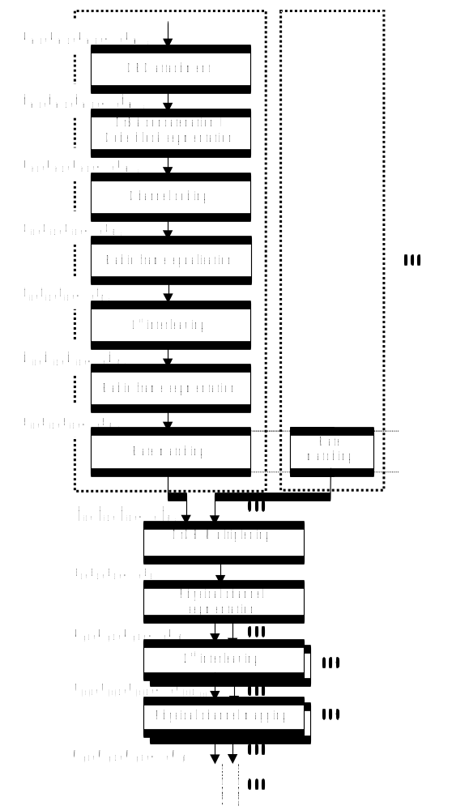

Figure 6–1. Transport channel multiplexing structure for uplink and downlink
Primarily, transport channels are multiplexed as described above, i.e. into one data stream mapped on one or several physical channels. However, an alternative way of multiplexing services is to use multiple CCTrCHs (Coded Composite Transport Channels), which corresponds to having several parallel multiplexing chains as in Figure 6-1, resulting in several data streams, each mapped to one or several physical channels.

Error detection
Error detection is provided on transport blocks through a Cyclic Redundancy Check. The CRC is 24, 16, 8 or 0 bits and it is signalled from higher layers what CRC length that should be used for each transport channel.

CRC calculation
The entire transport block is used to calculate the CRC parity bits for each transport block. The parity bits are generated by one of the following cyclic generator polynomials:
g_{CRC24}(D) = D²⁴ + D²³ + D⁶ + D⁵ + D + 1
g_{CRC16}(D) = D¹⁶ + D¹² + D⁵ + 1
g_{CRC8}(D) = D⁸ + D⁷ + D⁴ + D³ + D + 1
Denote the bits in a transport block delivered to layer 1 by 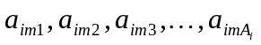, and the parity bits by 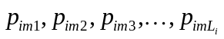. A_{i} is the length of a transport block of TrCH i, m is the transport block number, and L_{i} is 24, 16, 8, or 0 depending on what is signalled from higher layers.
The encoding is performed in a systematic form, which means that in GF(2), the polynomial

yields a remainder equal to 0 when divided by g_{CRC24}(D), polynomial
yields a remainder equal to 0 when divided by g_{CRC16}(D), and polynomial
yields a remainder equal to 0 when divided by g_{CRC8}(D).

Relation between input and output of the Cyclic Redundancy Check
Bits delivered to layer 1 are denoted 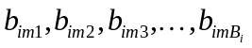, where B_{i}=A_{i}+L_{i.} The relation between a_{imk} and b_{imk} is:
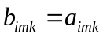 k = 1, 2, 3, …, A_{i}
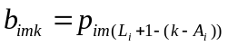 k = A_{i} + 1, A_{i} + 2, A_{i} + 3, …, A_{i} + L_{i}

Transport block concatenation and code block segmentation
All transport blocks in a TTI are serially concatenated. If the number of bits in a TTI is larger than Z, then code block segmentation is performed after the concatenation of the transport blocks. The maximum size of the code blocks depend on if convolutional or turbo coding is used for the TrCH.

Concatenation of transport blocks
The bits input to the transport block concatenation are denoted by 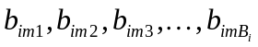 where i is the TrCH number, m is the transport block number, and B_{i} is the number of bits in each block (including CRC). The number of transport blocks on TrCH i is denoted by M_{i}. The bits after concatenation are denoted by 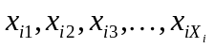, where i is the TrCH number and X_{i}=M_{i}B_{i}. They are defined by the following relations:
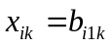 k = 1, 2, …, B_{i}
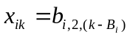 k = B_{i} + 1, B_{i} + 2, …, 2B_{i}
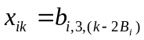 k = 2B_{i} + 1, 2B_{i} + 2, …, 3B_{i}
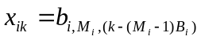 k = (M_{i} – 1)B_{i} + 1, (M_{i} – 1)B_{i} + 2, …, M_{i}B_{i}

Code block segmentation
< Note: It is assumed that filler bits are set to 0 >
Segmentation of the bit sequence from transport block concatenation is performed if X_{i}>Z. The code blocks after segmentation are of the same size. The number of code blocks on TrCH i is denoted by C_{i}. If the number of bits input to the segmentation, X_{i}, is not a multiple of C_{i}, filler bits are added to the last block. The filler bits are transmitted and they are always set to 0. The maximum code block sizes are:
convolutional coding: Z = 512 – K_{tail}
turbo coding: Z = 5120 – K_{tail}
The bits output from code block segmentation are denoted by 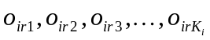, where i is the TrCH number, r is the code block number, and K_{i} is the number of bits.
Number of code blocks: C_{i} = ⎡X_{i} / Z⎤
Number of bits in each code block: K_{i} = ⎡X_{i} / C_{i}⎤
Number of filler bits: Y_{i} = C_{i}K_{i} – X_{i}
If X_{i} ≤ Z, then o_{i1k} = x_{ik}, and K_{i} = X_{i}.
If X_{i} ≥ Z, then
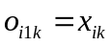 k = 1, 2, …, K_{i}
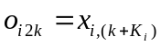 k = 1, 2, …, K_{i}
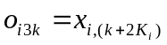 k = 1, 2, …, K_{i}
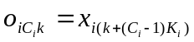 k = 1, 2, …, K_{i} – Y_{i}
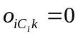 k = (K_{i} – Y_{i}) + 1, (K_{i} – Y_{i}) + 2, …, K_{i}

Channel coding
Code blocks are delivered to the channel coding block. They are denoted by 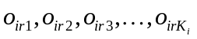, where i is the TrCH number, r is the code block number, and K_{i} is the number of bits in each code block. The number of code blocks on TrCH i is denoted by C_{i}. After encoding the bits are denoted by 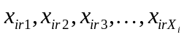. The encoded blocks are serially multiplexed so that the block with lowest index r is output first from the channel coding block. The bits output are denoted by 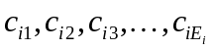, where i is the TrCH number and E_{i} = C_{i}X_{i}. The output bits are defined by the following relations:
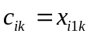 k = 1, 2, …, X_{i}
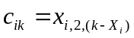 k = X_{i} + 1, X_{i} + 2, …, 2X_{i}
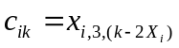 k = 2X_{i} + 1, 2X_{i} + 2, …, 3X_{i}
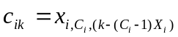 k = (C_{i} – 1)X_{i} + 1, (C_{i} – 1)X_{i} + 2, …, C_{i}X_{i}
The relation between o_{irk} and x_{irk} and between K_{i} and X_{i} is dependent on the channel coding scheme.
The following channel coding schemes can be applied to transport channels.
- Convolutional coding
- Turbo coding
- No channel coding

Table 6.2.3-1 Error Correction Coding Parameters
Transport channel type | Coding scheme | Coding rate
BCH | Convolutional code | 1/2
PCH | Convolutional code | 1/2
FACH | Convolutional code | 1/2
RACH | Convolutional code | 1/2
DCH | Convolutional code | 1/3, 1/2, or no coding
DCH | Turbo code | 1/3, or no coding

Convolutional Coding
- Constraint length K=9. Coding rates 1/2, 1/3.
- The configuration of the convolutional coder is presented in Fig. 6-2.
- The output from the convolutional coder shall be done in the order starting from output0, output1 and output2, output0, output1,…, output2. (When coding rate is 1/2, output is done up to output 1).
- The initial value of the shift register of the coder shall be “all 0”.
- K-1 tail bits (value 0) shall be added to the end of the code block before encoding.

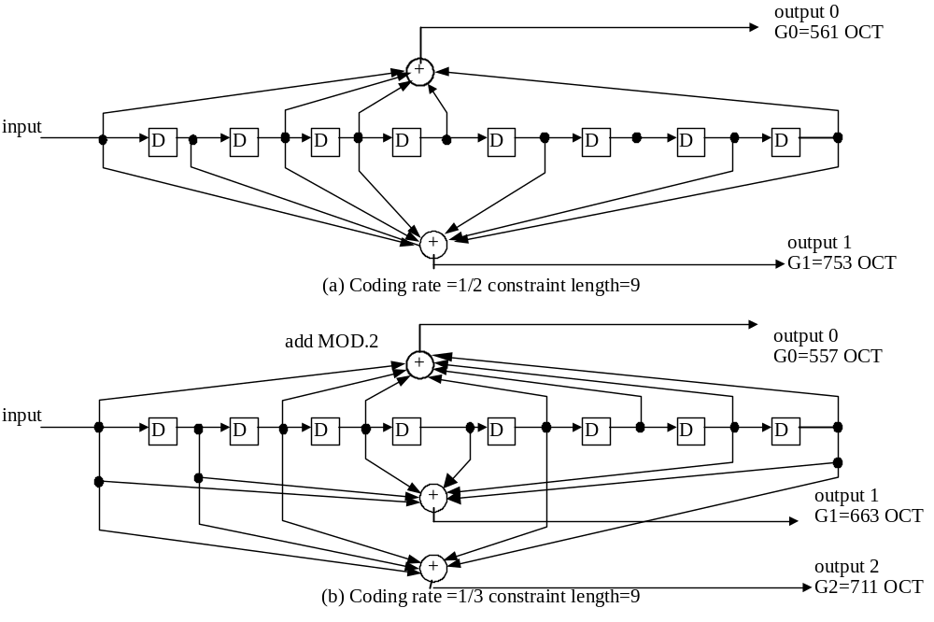Fig. 6-2 Convolutional Coder

Turbo coding

Turbo Coder

For data services requiring quality of service between 10⁻³ and 10⁻⁶ BER inclusive, parallel concatenated convolutional code (PCCC) with 8-state constituent encoders is used.
The transfer function of the 8-state constituent code for PCCC is
G(D)=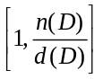
where,
d(D)=1+D²+D³
n(D)=1+D+D³.
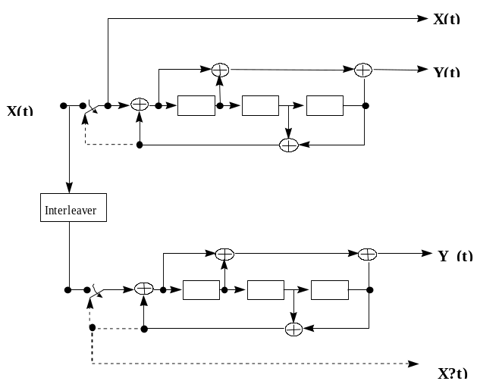
Figure 6-3. Structure of the 8 state PCCC encoder (dotted lines effective for trellis termination only)
The initial value of the shift registers of the PCCC encoder shall be all zeros.
The output of the PCCC encoder is punctured to produce coded bits corresponding to the desired code rate 1/3. For rate 1/3, none of the systematic or parity bits are punctured, and the output sequence is X(0), Y(0), Y’(0), X(1), Y(1), Y’(1), etc.

Trellis termination in Turbo code
Trellis termination is performed by taking the tail bits from the shift register feedback after all information bits are encoded . Tail bits are added after the encoding of information bits.
Trellis termination for PCCC
The first three tail bits shall be used to terminate the first constituent encoder (upper switch of Figure 6-3 in lower position) while the second constituent encoder is disabled. The last three tail bits shall be used to terminate the second constituent encoder (lower switch of Figure 6-3 in lower position) while the first constituent encoder is disabled.
The transmitted bits for trellis termination shall then be
X(t) Y(t) X(t+1) Y(t+1) X(t+2) Y(t+2) X’(t) Y’(t) X’(t+1) Y’(t+1) X’(t+2) Y’(t+2).

Turbo code internal interleaver
Figure 6-5 depicts the overall 8 State PCCC Turbo coding scheme including Turbo code internal interleaver. The Turbo code internal interleaver consists of mother interleaver generation and pruning. For arbitrary given block length K, one mother interleaver is selected from the 134 mother interleavers set. The generation scheme of mother interleaver is described in section 6.2.3.2.3.1. After the mother interleaver generation, l-bits are pruned in order to adjust the mother interleaver to the block length K. The definition of l is shown in section 6.2.3.2.3.2..
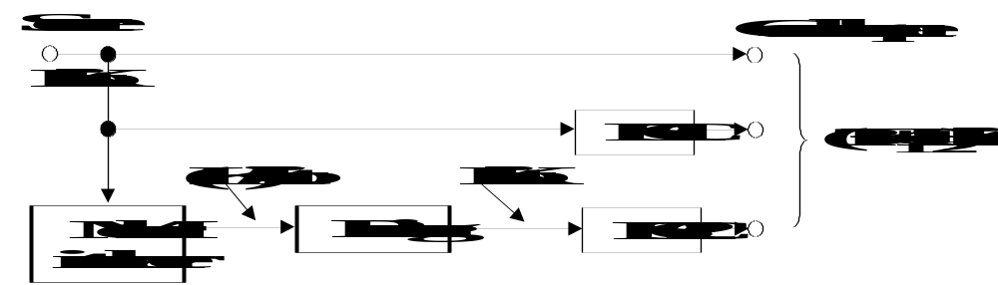
Figure 6-4. Overall 8 State PCCC Turbo Coding

6.2.3.2.3.1 Mother interleaver generation
The interleaving consists of three stages. In first stage, the input sequence is written into the rectangular matrix row by row. The second stage is intra-row permutation. The third stage is inter-row permutation. The three-stage permutations are described as follows, the input block length is assumed to be K (320 to 5114 bits).

First Stage:
- Determine a row number R such that
R=10 (K = 481 to 530 bits; Case-1)
R=20 (K = any other block length except 481 to 530 bits; Case-2)
- Determine a column number C such that
Case-1; C = p = 53
Case-2;
- find minimum prime p such that,
0 =< (p+1)-K/R
(ii) if (0 =< p-K/R) then go to (iii)
else C = p+1.
(iii) if (0 =< p-1-K/R) then C=p-1.
else C = p.
- The input sequence of the interleaver is written into the RxC rectangular matrix row by row.

Second Stage:
A. If C = p
- Select a primitive root g₀ from Table 6.2.2-2.
- Construct the base sequence c(i) for intra-row permutation as:
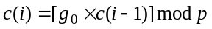, i =1,2,…(p-2)., c(0) = 1.
- Select the minimum prime integer set {q_{j} } (j=1,2,…R-1) such that
g.c.d{q_{j}, p-1} =1
q_{j} > 6
q_{j} > q_{(j-1)}
where g.c.d. is greatest common divider. And q₀ = 1.
- The set {q_{j}} is permuted to make a new set {p_{j}} such that
p_{P(j)} = q_{j} , j = 0, 1, …. R-1,
where P(j) is the inter-row permutation pattern defined in the third stage.
- Perform the j-th (j = 0,1, 2, …, C-1) intra-row permutation as:
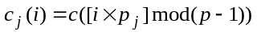, i =0,1,2,…, (p-2)., and c_{j}(p-1) = 0,
where c_{j}(i) is the input bit position of i-th output after the permutation of j-th row.

B. If C = p+1
(B-1) Same as case A-1.
(B-2) Same as case A-2.
(B-3) Same as case A-3.
(B-4) Same as case A-4.
(B-5) Perform the j-th (j = 0,1, 2, …, R-1) intra-row permutation as:
, i =0,1,2,…, (p-2)., c_{j}(p-1) = 0, and c_{j}(p) = p,
where c_{j}(i) is the input bit position of i-th output after the permutation of j-th row.
(B-6) If (K = C x R) then exhange c_{R-1}(p) with c_{R-1}(0).

C. If C = p-1
- Same as case A-1.
- Same as case A-2.

- Same as case A-3.
- Same as case A-4.
- Perform the j-th (j = 0,1, 2, …, R-1) intra-row permutation as:
-1, i =0,1,2,…, (p-2).,
where c_{j}(i) is the input bit position of i-th output after the permutation of j-th row.

Third Stage:
Perform the inter-row permutation based on the following P(j) (j=0,1, ..., R-1) patterns, where P(j) is the original row position of the j-th permuted row.
P_{A}: {19, 9, 14, 4, 0, 2, 5, 7, 12, 18, 10, 8, 13, 17, 3, 1, 16, 6, 15, 11} for R=20
P_{B}: {19, 9, 14, 4, 0, 2, 5, 7, 12, 18, 16, 13, 17, 15, 3, 1, 6, 11, 8, 10} for R=20
P_{C}: {9, 8, 7, 6, 5, 4, 3, 2, 1, 0} for R=10

The usage of these patterns is as follows:
Block length K: P(j)
320 to 480-bit: P_{A}
481 to 530-bit: P_{C}
531 to 2280-bit: P_{A}
2281 to 2480-bit: P_{B}
2481 to 3160-bit: P_{A}
3161 to 3210-bit: P_{B}
3211 to 5114-bit: P_{A}
(2) The output of the mother interleaver is the sequence read out column by column from the permuted R C matrix.

Table 6.2.2-2. Table of prime p and associated primitive root
p | g_{o} | P | g_{o} | p | g_{o} | P | g_{o} | p | g_{o}
17 | 3 | 59 | 2 | 103 | 5 | 157 | 5 | 211 | 2
19 | 2 | 61 | 2 | 107 | 2 | 163 | 2 | 223 | 3
23 | 5 | 67 | 2 | 109 | 6 | 167 | 5 | 227 | 2
29 | 2 | 71 | 7 | 113 | 3 | 173 | 2 | 229 | 6
31 | 3 | 73 | 5 | 127 | 3 | 179 | 2 | 233 | 3
37 | 2 | 79 | 3 | 131 | 2 | 181 | 2 | 239 | 7
41 | 6 | 83 | 2 | 137 | 3 | 191 | 19 | 241 | 7
43 | 3 | 89 | 3 | 139 | 2 | 193 | 5 | 251 | 6
47 | 5 | 97 | 5 | 149 | 2 | 197 | 2 | 257 | 3
53 | 2 | 101 | 2 | 151 | 6 | 199 | 3

6.2.3.2.3.2 Definition of the number of pruning bits
The output of the mother interleaver is pruned by deleting the l-bits in order to adjust the mother interleaver to the block length K, where the deleted bits are non-existent bits in the input sequence. The pruning bits number l is defined as:
l = RC – K,
where R is the row number and C is the column number defined in section 6.2.3.2.3.1.

Radio frame size equalisation
Radio frame size equalisation is padding the input bit sequence in order to ensure that the output can be segmented in F_{i} data segments of same size as described in the section 6.2.6.
The input bit sequence to the radio frame size equalisation is denoted by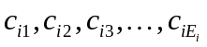, where i is TrCH number and E_{i} the number of bits. The output bit sequence is denoted by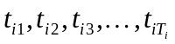, where T_{i} is the number of bits. The output bit sequence is derived as follows:
t_{ik} = c_{ik,} for k = 1… E_{i} and
t_{ik} = {0 | 1} for k= E_{i} +1… T_{i}, if E_{i} < T_{i}
where
T_{i} = F_{i} * N_{i} and
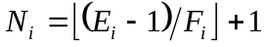 is the number of bits per segment after size equalisation.

1st interleaving
The 1st interleaving is a block interleaver with inter-column permutations. The input bit sequence to the 1st interleaver is denoted by 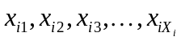, where i is TrCH number and X_{i} the number of bits (at this stage X_{i} is assumed and guaranteed to be an integer multiple of TTI). The output bit sequence is derived as follows:
- Select the number of columns C_{I} from Table 6.2.5-1.
- Determine the number of rows R_{I} defined as R_{I} = X_{i}/C_{I}
- Write the input bit sequence into the R_{I} C_{I} rectangular matrix row by row starting with bit 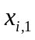 in the first column of the first row and ending with bit 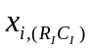 in column C_{I} of row R_{I}:
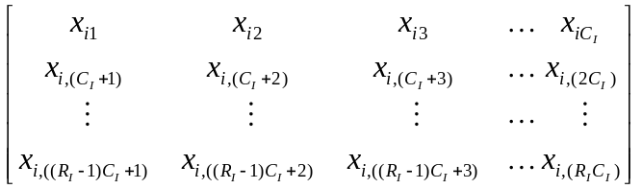
- Perform the inter-column permutation based on the pattern {P₁ (j)} (j=0,1, …, C-1) shown in Table 6.2.5-1, where P₁(j) is the original column position of the j-th permuted column. After permutation of the columns, the bits are denoted by y_{ik}:
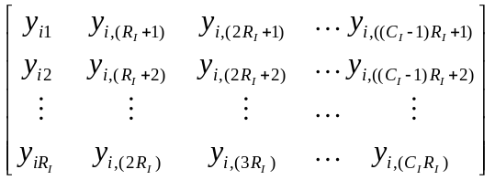
- Read the output bit sequence 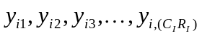 of the 1st interleaving column by column from the inter-column permuted R_{I} C_{I} matrix. Bit 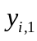 corresponds to the first row of the first column and bit 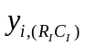 corresponds to row R_{I} of column C_{I}.

The bits input to the 1st interleaving are denoted by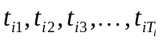, where i is the TrCH number and E_{i} the number of bits. Hence, x_{ik} = t_{ik} and X_{i} = T_{i}.
The bits output from the 1st interleaving are denoted by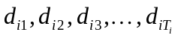, and d_{ik} = y_{ik}.

Table 6.2.5-1
Interleaving span | Column number C₁ | Inter-column permutation patterns
10 ms | 1 | {0}
20 ms | 2 | {0,1}
40 ms | 4 | {0,2,1,3}
80 ms | 8 | {0,4,2,6,1,5,3,7}

Radio frame segmentation
When the transmission time interval is longer than 10 ms, the input bit sequence is segmented and mapped onto consecutive radio frames. Following radio frame size equalisation the input bit sequence length is guaranteed to be an integer multiple of F_{i}.
The input bit sequence is denoted by where i is the TrCH number and X_{i} is the number bits. The Fi output bit sequences per TTI are denoted by 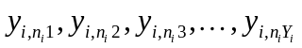where n_{i} is the radio frame number in current TTI and Y_{i} is the number of bits per radio frame for TrCH i. The output sequences are defined as follows:
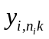= 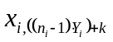, n_{i} = 1…F_{i}, j = 1…Y_{i}
where
Y_{i} = (X_{i} / F_{i}) is the number of bits per segment,
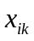 is the k^{th} bit of the input bit sequence and
is the k^{th} bit of the output bit sequence corresponding to the n^{th} radio frame
The n_{i} –th segment is mapped to the n_{i} –th radio frame of the transmission time interval.
The input bit sequence to the radio frame segmentation is denoted by 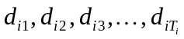, where i is the TrCH number and T_{i} the number of bits. Hence, x_{ik} = d_{ik} and X_{i} = T_{i}.
The output bit sequence corresponding radio frame n_{i} is denoted by 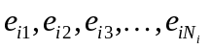, where i is the TrCH number and N_{i} is the number of bits. Hence, 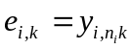and N_{i} = Y_{i}.

Rate matching
Rate matching means that bits on a transport channel are repeated or punctured. Higher layers assign a rate-matching attribute for each transport channel. This attribute is semi-static and can only be changed through higher layer signalling. The rate-matching attribute is used when the number of bits to be repeated or punctured is calculated.
The number of bits on a transport channel can vary between different transmission time intervals. When the number of bits between different transmission time intervals is changed, bits are repeated to ensure that the total bit rate after second multiplexing is identical to the total channel bit rate of the allocated dedicated physical channels.
Notation used in Section 6.2.7 and subsections:

N_{ij}: Number of bits in a radio frame before rate matching on transport channel i with transport format combination j .
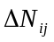: If positive - number of bits to be repeated in each radio frame on transport channel i with transport format combination j.
If negative - number of bits to be punctured in each radio frame on transport channel i with transport format combination j.
RM_{i}: Semi-static rate matching attribute for transport channel i. Signalled from higher layers.
PL: Puncturing limit for uplink. This value limits the amount of puncturing that can be applied in order to minimise the number of dedicated physical channels. Signalled from higher layers.
N_{data,j}: Total number of bits that are available for a CCTrCH in a radio frame with transport format combination j.
I: Number of transport channels in a CCTrCH.
Z_{mj}: Intermediate calculation variable.
F_{i}: Number of radio frames in the transmission time interval of transport channel i.
n_{i} : Radio frame number in the transmission time interval of transport channel i (0 ≤ n_{i} < F_{i}).
Q: Average puncturing distance.
I_{F}(n_{i}): The inverse interleaving function of the 1st interleaver (note that the inverse interleaving function is identical to the interleaving function itself for the 1st interleaver).
S(n_{i}): The shift of the puncturing pattern for radio frame n_{i} .
TF_{i}(j): Transport format of transport channel i for the transport format combination j.
TFS(i): The set of transport format indexes l for TrCH i.
E_{ini}: Initial value of variable e in the rate matching pattern determination algorithm of section 6.2.7.3.
X: Systematic bit in 6.2.3.2.1.
Y: 1st parity bit (from the upper Turbo constituent encoder) in section 6.2.3.2.1.
Y’: 2nd parity bit (from the lower Turbo constituent encoder) in section 6.2.3.2.1.
Note: Time index t in 6.2.3.2.1 is omitted for simplify the rate matching description

Determination of rate matching parameters
The following relations are used when calculating the rate-matching pattern:
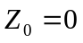
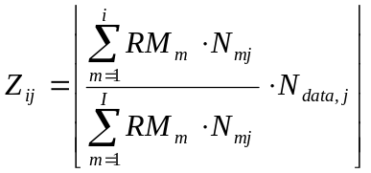 for all i = 1 .. I
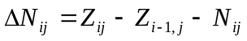 for all i = 1 .. I
Puncturing can be used to minimise the number of required transmission capacity. The maximum amount of puncturing that can be applied is signalled at connection setup from higher layers and denoted by PL. The possible values for N_{data} in uplink and downlink depend on the dedicated physical channels which are assigned to the link, respectively. The supported set of N_{data} , denoted SET0, depends on the UE capabilities. N_{data,j} for the transport format combination j is determined by executing the following algorithm:
SET1 = { N_{data} in SET0 such that 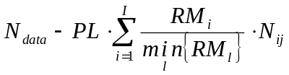 is non negative }
N_{data,j} = min SET1
The number of bits to be repeated or punctured, ΔN_{ij}, within one radio frame for each transport channel i is calculated with the relations given at the beginning of this section for all possible transport format combinations j and selected every radio subframe. For each radio frame, the rate matching pattern is calculated with the algorithm in Section 6.2.6.2, where ΔN = ΔN_{ij} and N = N_{ij}.
Additionally, the following parameters are needed:
For convolutional codes, a=2 for the rate matching algorithm in section 6.2.7.3.
If q is even
Then q' = q – gcd(q, F_{i})/F_{I} -- where gcd(q, F_{I}) means greatest common divisor of q and F_{I}
-- note that q' is not an integer, but a multiple of 1/8.
Else
q' = q
endif
for l=0 to F_{I} -1
end for
For each radio frame, the rate-matching pattern is calculated with the algorithm in section 6.2.7.3, where:
ΔN = ΔN_{i,j}
N = N_{i,j,} and
e_{ini} = (a⋅S(n_{i})⋅|ΔN| + N) mod a⋅N, if e_{ini} =0 then e_{ini} = a⋅N.
For turbo codes, if repetition is to be performed, such as ΔN_{i,j} >0, parameters for turbo codes are the same as parameter for convolutional codes. If puncturing is to be performed, parameters are as follows.
A = 2 for Y parity sequence, and
a = 1 for Y’ parity sequence.
For each radio frame, the rate-matching pattern is calculated with the algorithm in section 6.2.7.3, where:
ΔN =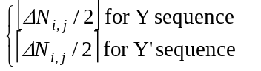
N = ⎣N_{i,j} /3⎦ ,
q = ⎣N /|ΔN| ⎦
if(q2)
for x=0 to F_{i}-1
if(Y sequence)
S[I_{F}[(3x+1) mod F_{i}]] = x mod 2;
if(Y’ sequence)
S[I_{F} [(3x+2) mod F_{i}]] = x mod 2;
end for
else
if q is even
then q' = q – gcd(q, F_{i})/ F_{i} -- where gcd (q, F_{i}) means greatest common divisor of q and F_{i}
-- note that q' is not an integer, but a multiple of 1/8
else q’ = q
endif
for x=0 to F_{i} –1
r = ⎡ x*q’⎤ mod F_{i};
if(Y sequence)
S[I_{F}[(3r+1) mod F_{i}]] = ⎡ x*q’⎤ div F_{i};
if(Y’ sequence)
S[I_{F}[(3r+2) mod F_{i} ]] = ⎡ x*q’⎤ div F_{i};
endfor
endif

e_{ini} = (a⋅S(n_{i})⋅|ΔN| + N) mod a⋅N, if e_{ini} = 0 then e_{ini} = a⋅N.

Bit separation for rate matching
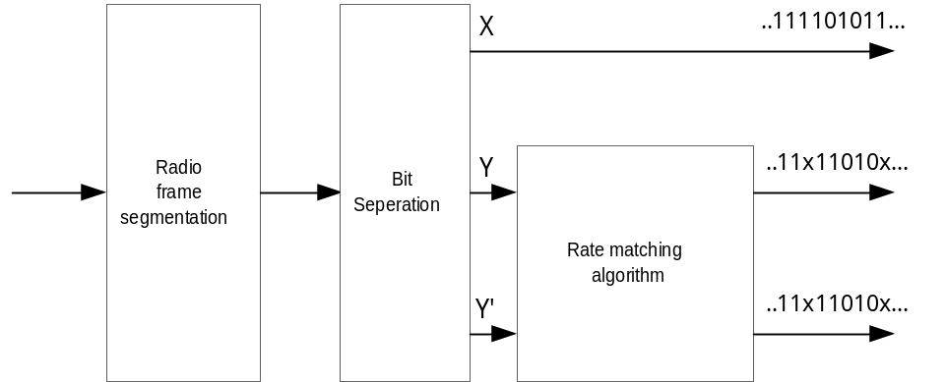
Figure 6-5. Overall rate matching block diagram after first interleaving where x denotes punctured bit.
Rate matching puncturing for Turbo codes is applied separately to Y and Y’ sequences. No puncturing is applied to X sequence. Therefore, it is necessary to separate X, Y, and Y’ sequences before rate matching is applied.
There are two different alternation patterns in bit stream from Radio frame segmentation according to the TTI of a TrCH as shown in Table 6.2.7-1.
Table 6.2.7-1 Alternation patterns of bits from radio frame segmentation
TTI (msec) | Alternation patterns
10, 40 | … X,Y,Y’,…
20, 80 | … X,Y’,Y,…

In addition, each radio frame of a TrCH starts with different initial parity type. Table 6.2.7-2 shows the initial parity type of each radio frame of a TrCH with TTI = {10, 20, 40, 80} msec.
Table 6.2.7-2 Initial parity type of radio frames of TrCH
TTI (msec) | Radio frame indexes (n_{i})
TTI (msec) | 0 | 1 | 2 | 3 | 4 | 5 | 6 | 7
10 | X | NA | NA | NA | NA | NA | NA | NA
20 | X | Y | NA | NA | NA | NA | NA | NA
40 | X | Y’ | Y | X | NA | NA | NA | NA
80 | X | Y | Y’ | X | Y | Y’ | X | Y

Table 6.2.7-1 and 6.2.7-2 defines a complete output bit pattern from Radio frame segmentation.
Ex. 1. TTI = 40 msec, n_{i} = 2
Radio frame pattern: Y, Y’, X, Y, Y’, X, Y, Y’, X, …
Ex. 2 TTI = 40 msec, n_{i} = 3
Radio frame pattern: X, Y, Y’, X, Y, Y’, X, Y, Y’, X, …
Therefore, bit separation is achieved with the alternative selection of bits with the initial parity type and alternation pattern specified in Table 6.2.7-1 and 6.2.7-2 according to the TTI and n_{i} of a TrCH.

Rate matching pattern determination
The bits input to the rate matching are denoted by 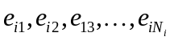, where i is the TrCH with N = N_{ij} = N_{i}. Here N is the parameter given in section 6.2.7.1.The bits output from the rate matching are denoted by 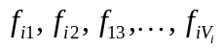, where i is the TrCH number and V_{i}=N+ΔN = N_{ij}+ΔN_{ij} .

Note that the transport format combination number j for simplicity has been left out in the bit numbering.
The rate matching rule is as follows:
if puncturing is to be performed

y = -ΔN
e = e_{ini} -- initial error between current and desired puncturing ratio
m = 1 -- index of current bit
do while m <= N
e = e – a * y -- update error
if e <= 0 then -- check if bit number m should be punctured
puncture bit x_{i,m}
e = e + a*N -- update error
end if
m = m + 1 -- next bit
end do
else
y = ΔN

e = e_{ini} -- initial error between current and desired puncturing ratio
m = 1 -- index of current bit
do while m <= N
e = e – a * y -- update error
do while e <= 0 -- check if bit number m should be repeated
repeat bit x_{i,m}
e = e + a*N -- update error
enddo
m = m + 1 -- next bit
end do
end if
A repeated bit is placed directly after the original one.

TrCH multiplexing
Every 10 ms, one radio frame from each TrCH is delivered to the TrCH multiplexing. These radio frames are serially multiplexed into a coded composite transport channel (CCTrCH).
The bits input to the TrCH multiplexing are denoted by 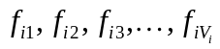, where i is the TrCH number and V_{i} is the number of bits in the radio frame of TrCH i. The number of TrCHs is denoted by I. The bits output from TrCH multiplexing are denoted by 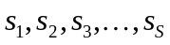, where S is the number of bits, i.e. 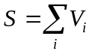. The TrCH multiplexing is defined by the following relations:
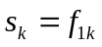 k = 1, 2, …, V₁
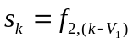 k = V₁+1, V₁+2, …, V₁+V₂
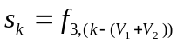 k = (V₁+V₂)+1, (V₁+V₂)+2, …, (V₁+V₂)+V₃
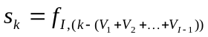 k = (V₁+V₂+…+V_{I-1})+1, (V₁+V₂+…+V_{I-1})+2, …, (V₁+V₂+…+V_{I-1})+V_{I}

Physical channel segmentation
When more than one PhCH is used, physical channel segmentation divides the bits among the different PhCHs. The bits input to the physical channel segmentation are denoted by 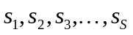, where S is the number of bits input to the physical channel segmentation block. The number of PhCHs is denoted by P.
The bits after physical channel segmentation are denoted 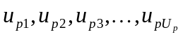, where p is PhCH number and U_{p} is the in general variable number of bits in the respective radio frame for each PhCH. The relation between s_{k} and u_{pk} is given below.

Bits on first PhCH after physical channel segmentation:
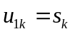 k = 1, 2 , …, U₁

Bits on second PhCH after physical channel segmentation:
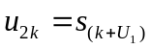 k = 1, 2 , …, U₂
…

Bits on the P^{th} PhCH after physical channel segmentation:
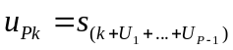 k = 1, 2 , …, U_{P}

2nd interleaving
The 2nd interleaving can be applied jointly to all data bits transmitted during one frame, or separately within each timeslot, on which the CCTrCH is mapped. The selection of the 2nd interleaving scheme is controlled by higher layer.

Frame related 2nd interleaving
In case of frame related interleaving, the bits input to the 2nd interleaver are denoted 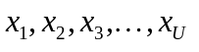, where U is the total number of bits after TrCH multiplexing transmitted during the respective radio frame.
The relation between x_{k} and the bits u_{pk} in the respective physical channels is given below:

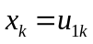 k = 1, 2 , …, U₁
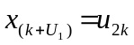 k = 1, 2 , …, U₂
…
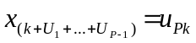 k = 1, 2 , …, U_{P}

The following steps have to be performed once for each CCTrCH:
- Set the number of columns C₂ = 30. The columns are numbered 0, 1, 2, …, C₂-1 from left to right.
- Determine the number of rows R₂ by finding minimum integer R₂ such that
U ≤ R₂C₂.
- The bits input to the 2nd interleaving are written into the R₂ C₂ rectangular matrix row by row. 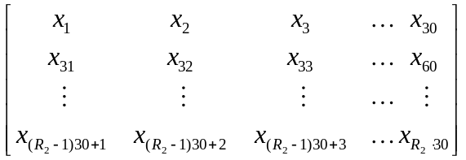
- Perform the inter-column permutation based on the pattern {P₂(j)} (j = 0, 1, …, C₂-1) that is shown in Table 6.2.9-1, where P₂(j) is the original column position of the j-th permuted column. After permutation of the columns, the bits are denoted by y_{k}.
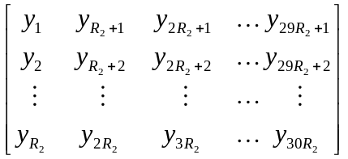
- The output of the 2nd interleaving is the bit sequence read out column by column from the inter-column permuted R₂ C₂ matrix. The output is pruned by deleting bits that were not present in the input bit sequence, i.e. bits y_{k} that corresponds to bits x_{k} with k>U are removed from the output. The bits after 2nd interleaving are denoted by 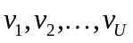, where v₁ corresponds to the bit y_{k} with smallest index k after pruning, v₂ to the bit y_{k} with second smallest index k after pruning, and so on.

Timeslot related 2nd interleaving
In case of timeslot related 2nd interleaving, the bits input to the 2nd interleaver are denoted 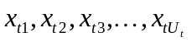, where t refers to a certain timeslot, and U_{t} is the number of bits transmitted in this timeslot during the respective radio frame.
In each timeslot t the relation between x_{tk} and u_{pk} is given below with P_{t} refering to the number of physical channels within the respective timeslot:
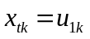 k = 1, 2 , …, 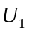
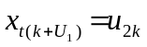 k = 1, 2 , …, 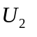
…
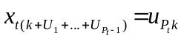 k = 1, 2 , …, 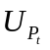

The following steps have to be performed for each timeslot t, on which the respective CCTrCH is mapped:
- Set the number of columns C₂ = 30. The columns are numbered 0, 1, 2, …, C₂-1 from left to right.
- Determine the number of rows R₂ by finding minimum integer R₂ such that
U_{t} ≤ R₂C₂.
- The bits input to the 2nd interleaving are written into the R₂ C₂ rectangular matrix row by row. 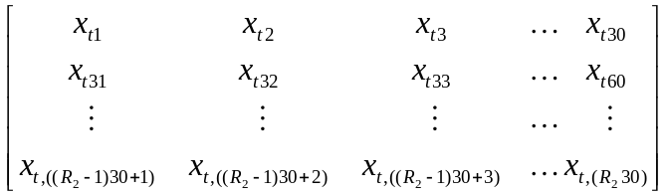
- Perform the inter-column permutation based on the pattern {P₂(j)} (j = 0, 1, …, C₂-1) that is shown in Table 6.2.9-1, where P₂(j) is the original column position of the j-th permuted column. After permutation of the columns, the bits are denoted by y_{tk}.
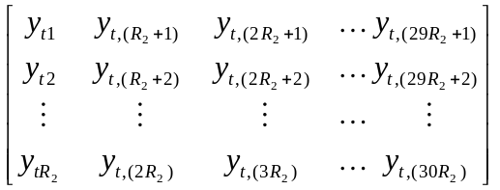
The output of the 2nd interleaving is the bit sequence read out column by column from the inter-column permuted R₂ C₂ matrix. The output is pruned by deleting bits that were not present in the input bit sequence, i.e. bits y_{tk} that corresponds to bits x_{tk} with k>U_{t} are removed from the output. The bits after 2nd interleaving are denoted by 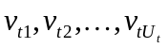, where v_{t1} corresponds to the bit y_{tk} with smallest index k after pruning, v_{t2} to the bit y_{tk} with second smallest index k after pruning, and so on.

Table 6.2.10-1

Column number C₂ | Inter-column permutation pattern
30 | {0, 20, 10, 5, 15, 25, 3, 13, 23, 8, 18, 28, 1, 11, 21,  6, 16, 26, 4, 14, 24, 19, 9, 29, 12, 2, 7, 22, 27, 17}

Physical channel mapping
The PhCH for both uplink and downlink is defined in [6]. The bits after physical channel mapping are denoted by 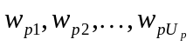, where p is the PhCH number and U_{p} is the number of bits in one radio frame for the respective PhCH. The bits w_{pk} are mapped to the PhCHs so that the bits for each PhCH are transmitted over the air in ascending order with respect to k. The mapping scheme depends on the applied 2nd interleaving scheme.

Mapping scheme after frame related 2nd interleaving
The following mapping rule is applied:
Bits on first PhCH after physical channel mapping:
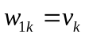 k = 1, 2 , …, U₁
Bits on second PhCH after physical channel mapping:
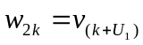 k = 1, 2 , …, U₂
…
Bits on the P^{th} PhCH after physical channel mapping:
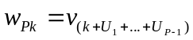 k = 1, 2 , …, U_{P}

Mapping scheme after timeslot related 2nd interleaving
For each timeslot only those physical channels with p = 1, 2, …, P_{t} are considered respectively, which are transmitted in that timeslot, and the following mapping scheme is applied:

Bits on first PhCH in timeslot t after physical channel mapping:
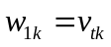 k = 1, 2 , …, 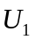
Bits on second PhCH in timeslot t after physical channel mapping:
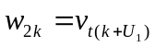 k = 1, 2 , …, 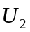
…
Bits on the PhCH P_{t} in timeslot t after physical channel mapping:
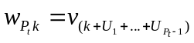 k = 1, 2 , …,

Multiplexing of different transport channels onto one CCTrCH, and mapping of one CCTrCH onto physical channels
Different transport channels can be encoded and multiplexed together into one Coded Composite Transport Channel (CCTrCH). The following rules shall apply to the different transport channels which are part of the same CCTrCH:
- Transport channels multiplexed into one CCTrCh should have co-ordinated timings in the sense that transport blocks arriving from higher layers on different transport channels of potentially different transmission time intervals shall have aligned transmission time instants as shown in figure 6-6.
- Different CCTrCHs cannot be mapped onto the same physical channel.
- One CCTrCH shall be mapped onto one or several physical channels.
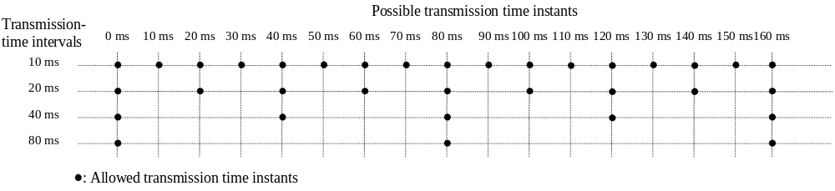
Figure 6-6: Possible transmission time instants regarding CCTrCH
- Dedicated Transport channels and common transport channels cannot be multiplexed into the same CCTrCH.
- For the common transport channels, only the FACH and PCH may belong to the same CCTrCH.
- Each CCTrCH carrying a BCH shall carry only one BCH and shall not carry any other Transport Channel.
- Each CCTrCH carrying a RACH shall carry only one RACH and shall not carry any other Transport Channel.
Hence, there are two types of CCTrCH
CCTrCH of dedicated type, corresponding to the result of coding and multiplexing of one or several DCH.
CCTrCH of common type, corresponding to the result of the coding and multiplexing of a common channel, i.e. RACH and USCH in the uplink and DSCH, BCH, FACH or PCH in the downlink, respectively.
There may be one TFCI for each CCTrCH of dedicated type as well as for USCH- and DSCH-CCTrCHs.

Allowed CCTrCH combinations for one UE

Allowed CCTrCH combinations on the uplink
The following CCTrCH combinations for one UE are allowed, also simultaneously:
- several CCTrCH of dedicated type
- several CCTrCH of common type

Allowed CCTrCH combinations on the downlink
The following CCTrCH combinations for one UE are allowed, also simultaneously:
- several CCTrCH of dedicated type
several CCTrCH of common type

Transport format detection
Transport format detection can be performed both with and without Transport Format Combination Indicator (TFCI). If a TFCI is transmitted, the receiver detects the transport format combination from the TFCI. When no TFCI is transmitted, so called blind transport format detection is used, i.e. the receiver side uses the possible transport format combinations as a priori information or the transport format is informed to the receiver side through higher layer signalling at connection setup.

Blind transport format detection

Blind transport format detection may be performed in the receiver by trying all possible combinations of the transport format.

Explicit transport format detection based on TFCI

Transport Format Combination Indicator
The Transport Format Combination Indicator (TFCI) informs the receiver of the transport format combination of the CCTrCHs . As soon as the TFCI is detected, the transport format combination, and hence the individual transport channels' transport formats are known, and decoding of the transport channels can be performed.

Coding for layer 1 control

Coding of transport format combination indicator (TFCI)
The number of TFCI bits is variable and is set at the beginning of the call via higher layer signalling. Encoding of the TFCI bits depends on the number of them. If there are 6-10 bits of TFCI the channel encoding is done as described in section Error: Reference source not found. Also specific coding of less than 6 bits is possible as explained in 6.3.1.3. For improved TFCI detection reliability repetition is used to increase the number of TFCI bits. Additionally, with any TFCI coding scheme it is assumed that in the receiver combining of two successive TFCI words will be performed if the shortest transmission time interval of any TrCH is at least 20 ms.

Default TFCI word
TFCI is encoded by the (32,10) sub-code of second order Reed-Muller code. The code words of the (32,10) sub-code of second order Reed-Muller code are linear combination of some among 10 basis sequences: all 1’s, 5 OVSF codes ( C₅(1), C₅(2), C₅(4), C₅(8), C₅(16)), and 4 masks (Mask1, Mask2, Mask3, Mask4). The 4 mask sequences are as follows in Table 6.3.1-1.
Table 6.3.1-1. Mask sequences
Mask 1 | 00101000011000111111000001110111
Mask 2 | 00000001110011010110110111000111
Mask 3 | 00001010111110010001101100101011
Mask 4 | 00011100001101110010111101010001

For information bits a₀ , a₁ , a₂ , a₃ , a₄ , a₅ , a₆ , a₇ , a₈ , a₉ (a₀ is LSB and a₉ is MSB), the encoder structure is as follows in Figure 6-7.
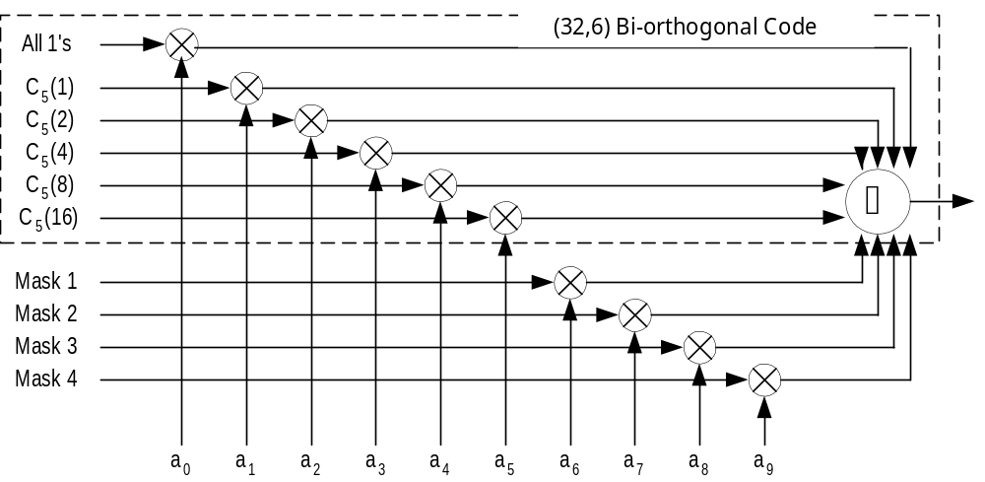
Figure 6-7. Encoder structure for (32,10) sub-code of second order Reed-Muller code

Coding of short TFCI lengths
If the number of TFCI bits is 1 or 2, then repetition will be used for coding. In this case each bit is repeated 3 times giving 4-bit transmission for a single TFCI bit and 8-bit transmission for 2 TFCI bits.
If the number of TFCI bits is in the range of 3 to 5, then one word of the biorthogonal (16,5) block code will be used.
The code words of the biorthogonal (16, 5) code are from two mutually biorthogonal sets, 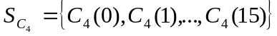 and its binary complement, 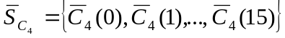. Words of set 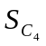 are from the level 4 of the code three, which is generated, using the short code generation method defined in TS 25.223. The mapping of information bits to code words is shown in the Table 6.3.1-2.
Table 6.3.1- 2 Mapping of information bits to code words for biorthogonal (16, 5) code.
Information bits | Code word
00000 | 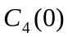
00001 | 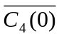
00010 | 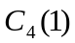
… | …
11101 | 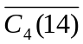
11110 | 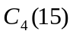
11111 | 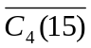

Operation of Transport-format-combination indicator (TFCI) in Split Mode
In the case of DCH in Split Mode, the UTRAN shall operate with as follows:
- If one of the links is associated with a DSCH, the TFCI code word may be split into two code words of length 16. The use of such a functionality shall be indicated by higher layer signalling.
TFCI information is encoded by biorthogonal (16, 5) block code. The code words of the biorthogonal (16, 5) code are from two mutually biorthogonal sets, and its binary complement, . Code words of set are from the level 16 of the code three of OVSF codes defined in document TS 25.213. The mapping of information bits to code words is shown in the Table 2.
Table 6.3.2-1: Mapping of information bits to code words for biorthogonal (16, 5) code
Information bits | Code word
00000
00001
00010
… | …
11101
11110
11111

History

Document history
V1.0.0 | 1999-07-29 | Document created based on the documents TS C.121(V1.10) and TS S1.22 (V2.00).
V1.1.0 | 1999-08-5 | Document created based on the documents TS C.121(V1.1.0) and discussion in the CWTS WG1 Ad Hoc1 #2 conference
V2.0.0 | 1999-09-06 | Updated based on the discussion in the CWTS WG1 Ad Hoc 1#3 conference.
V2.0.1 | 1999-09-28 | Updated based on the consideration of new chiprate.
V2.1.0 | 1999-10-2 | Chip rate change to 1.28Mcps
V2.2.0 | 1999-10-14 | Document accepted by CWTS WG1 Ad Hoc #4 and CWTS WG1#5, Beijing, Oct.14, 1999
The editor for CWTS TS C103 Multiplexing, channel coding and interleaving description (TD-SCDMA), is:
Zhang Jian
Beijing University of Posts & Telecommunications
Email: cmzhang@bupt.edu.cn
This document is written in Microsoft Word 97.

